ABSTRACT:

The Smart helmet with an Auto rescue emergency Web Application has been developed as a thought of responsibility towards the society. The purpose of this project to make the riders life secure and safe as the late arrival of the ambulance is the main issue and to overcome that we have many features in our helmet and application to lower the death risks. We applied the incremental methodology to develop the project. The Helmet has GPS, shock sensor, Bluetooth module, microphones, speakers , emergency button(starts rescue process) and a kill process button(stop button to stop rescue process).The shock after being identified will start the process to detect the rider’s location and will send the location to the ambulance station for help. The nearest ambulance station will assign the driver to perform this task at the same time the family member will also be acknowledged about accident. The driver’s status will be busy after being assigned the task and he can change his status after giving rescue to the victim.

**ACKNOWLEDGEMENT:**

First of all, I would like to pay deep sense of gratitude to **DR. ARIJ MEHMOOD HASAAN** gave us the opportunity to complete this project by accepting this idea and always sharing his experiences with us. And our supervisor ma’am **Ridha Fatima** she helped us with her valuable suggestions and the comments.

I would like to thanks the faculty **Syed Jamal Haider Zaidi** he shared his knowledge of hardware and refined our project idea to make it more convenient and effective despite of his busy schedule.

The Last but not least my family and the friends those encouraged and inspired me I present my gratitude to them.

INTRODUCTION:

The Smart helmet has been designed to provides safety to the bike riders it will protect the head injuries and to automatically detects location in case met with an accident and sends the rescue request to the ambulance web application. The smart helmet has shock sensor in it to identify the shock and if any case the sensor does not work the request can be send by an emergency button, and it also has button to stop this rescue process. The rescue task is assigned to the nearest station. The station will assign the task to the ambulance driver by using ambulance web application, along with the location of victim task is assigned to driver. The detected location and the ambulance’s driver information is sent to the family member of victim. The ambulance application can track the ambulance driver after the assignment of rescue task to driver whenever driver uses his panel. The driver can also change its status from busy to available after completing the task.

1. PROJECT OBJECTIVE:

The main objectives of Smart Helmet are following:

1.To minimize the death risks.

2. To provide safety and security to the bike riders

3. To identify the location of the victim in case of accident by using GPS.

4. To minimize the reach time towards the victim by automatically sending the rescue request to ambulance station.

5. To track the ambulance driver when the driver’s status is set to busy.

3. BACKGROUND:

According to the WHO (World Health Organization) by 2023 the fifth major cause of deaths will be the road accidents and in Pakistan more than 50% of accident reported because of motorbikes involvement. As motorbike is a two-wheeler journey rather than four that is why it is more likely to involve in an accident. According to the studies head is the prior part to get injured and most of the deaths occurred due to head injuries. Even if motor biker hits the car the rider will get more damage than the car driver. The government has made it mandatory for bike riders to wear helmet in Pakistan. The reasons for the accidents can be many. When accident occurs most of the people die because of the lack of the treatment on proper time because the helping and the rescue does not get the information on time or there maybe no one to help the rider. It is a social responsibility to do something about this. When the motor bikers meet with an accident the family members are not acknowledged nor the ambulance is informed to provider rescue to save the life. The helmet named as “smart” are present in the market but they do not provide the rescue they are designed for fulfilling the different purposes such as; showing the routes on front helmet screen based on augmented reality , making sure helmet mut be worn by rider, sensors placed inside the helmet for the alcohol detection, the helmet with the GPS and GSM to inform the family of rider about the accident. As in Pakistan the rescue is given by the Welfare like Edhi and Chippa they do not have any auto rescue system to reach the exact destination and they still perform all the operations manually.

4.PROBLEM:

It goes without saying that accidents are unpredictable and could prove fatal, life threatening and devastating to people and could impact people’s life physically mentally and financially. Although we can’t predict accidents and we can always minimize the ways the accidents could happen but cannot eliminate it completely hence we need a reactive approach to solve this problem which is to provide necessary medical care to the victim as soon as possible which starts by reaching of medical assistant to the patient or victim pronto. In Pakistan the common commute is motor cycles and people like to travel through different routes on motor cycles and sadly it is one of the most dangerous ways to travel but since it’s the cheapest people like to use it for travel purposes and it has also been reported that people traveling on motor cycles get into accident more often than any other vehicle and as in Pakistan the welfares provide rescue by sending their drivers with ambulance for the rescue but once the driver leaves for destination the ambulance stations cannot track him, so the ambulance station should have the technology to know the ambulance driver’s location. Again, accidental recovery using technology is the need of the hour without the prior consent of the person if the person has met with a traffic accident and fainted during the accident.

5.IMPORTANCE AND MOTIVATION:

Road accidents cause major deaths in Pakistan and our project smart helmet with an auto rescue system is a result of our social responsibility towards our society. As the human life is at stake and to minimize the death risks and to protect the human life we introduced this helmet and Web application to support this rescue process .Death risks can be minimize by this project Nothing is more important than a human life and we are motivated to contribute our part towards the society we designed this project in which helmet detecting location after accident and sending rescue request to the web application (used by the ambulance station) .The Ambulance station will sends the driver to the victim to help him.

2.TECHNOLOGY BACKGROUND:

2.1. OVERVIEW OF BASIC TECHNOLOGY:

2.1.1: TOOLS:

* Visual Studio 2017
* SSMS (Sql Server Management Studio)
* Python 3.7.0
* CSS
* ASP.Net Web
* C#
* Twilio Api
* Php
* JavaScript
* Raspberry pi 3
* Sublime text 3

**Visual Studio (2017):**

Visual Studio is an IDE (Integrated Development Environment) from Microsoft. It is used to develop the web application, web sites and mobile application. It is an open source platform which is free of cost.

Editions:

It has six Editions of Visual Studio.

* Professional:

It is usually for small team or a individual to use and develop existing applications to maintain or modernize them.

* Community:

It provides free IDE without any subscription and allows to develop web apps, websites, IOs windows apps etc. It is open source and supports the classroom environment.

* Test Professional:

It is used to test the hub of visual studio and to test all the process of planning, executing or tracking the central hub.

* Enterprise:

It supports the development, designing and execution of the complex enterprise applications. It is an end to end solution for any size of teams.

* MSDN Platform:

It is for the testing for a individual who does not need full features of visual studio.

* Team Foundation Server:

It is benefit for the large team and enables them to perform cross functionalities on project of all sizes.

**Twilio Api:**

Twilio is a Rest api and a cloud platform used for the communication and generating and receiving the messages. It is also used for calling, recording, text messaging and it is served over https, which ensures its security. It is integrated with ambulance app used to send message to the ambulance driver containing the location and then sending the message to the emergency contact containing driver’s and location details.

**Bluetooth:**

We have used the Bluetooth technology in smart helmet for the user’s comfort. The user will be able to connect its mobile with helmet to have talks on calls without removing the helmet. By turning the Bluetooth on, the smart phone and helmet will be in connection and using google map of smart phone the route instructions will be audio able to user as smart helmet has speakers and microphones placed in it so rider can reach the destination without looking at screen.

**GPS:**

The satellite-based navigation system GPS (Global Positioning System) to get the location of the victim in anywhere of the world without paying any cost. We used this to detect the accident location of the rider. We received the location in the form of coordinates such as longitude &latitude.

**Raspberry Pi 3 :**

To develop the IOT project using this instead of Arduino to provide more flexible and fast performance in GHz. We have programmed in python. The GPS connected to Raspberry Pi 3 will fetch the longitude, latitude and it will be saved in database.

**Shock sensor:**

The shock sensor is placed inside the helmet where it is the most probability of hitting hard. When It will detect the shock or the impact the buzzer will turn on as sign of initiation of rescue process.

**Problem Domain with HISTORICAL BACKGROUND:**

According to the WHO Pakistan is on 67th rank with higher rate of road accidents worldwide. The problem is the highest number of deaths caused by the road accidents due to the delay of medical attention. The bike rider’s involvement is mostly there at the accident and they become probably the victim because of the light weight of bike, a light hit or turn over can make their life at risk which almost cause them death. As accident can occur anywhere such as desolate place and no one can be there to help him nor to inform the family members. Another part of the problem is the welfares provide rescue and they are working manually till now. They receive calls with approximate location for rescue and they send their any driver with ambulance to perform this task. They have no such database, exact locations and not any way to track the driver after he leaves for task.

**HISTORICAL BACKGROUND:**

The Worlds first smart helmet was Skully AR-1 which was introduced in 2013.This motivation came from the incident of Marcus Weller (CEO and founder) of Skully in 2011 when he took his eye off for a moment from the road and got hit his bike on vehicle ahead of him. The Smart helmet had Bluetooth connectivity with phone, anti-fog, anti-glare, scratch resistant visor, GPS and 180-degree rear camera at his front. It became very popular and received a very warm response in 2013.

**ALL Similar Solutions:**

The Smart Helmet has been launched by many companies with different and modified features in it.

**Jarvish Smart Helmet:**

The Jarvish Smart helmet has been launched in Malaysia in 2017 By RT Ride Tech Motorsport. It has 2k and 120-degree wide angle camera voice activation command, ability to receive and to reject phone calls, and it is compatible with Apple Siri and Android’s Google Go. This feature allows riders to check on the weather, location of nearby petrol stations and location of food stalls, all through voice commands. This allows the rider to keep both hands on the handle bars. It has its own Application and can be downloaded to smart phones and very soon this application will allow the live streaming with the Facebook account of the rider. It also has a sensor whenever it will detect the shock or an impact the video will start as it has a Blackbox and the video will save in it. The sensor will directly inform the family by calling them out and will link up to rescue system and an insurance company.

**The Momentum EVO Smart Helmet:**

The Evolution of original Smart helmet has been launched by SENA. The Evo helmet has oval shape which improves placement of speakers and reduce the wind noise and this shape makes it easier to wear the helmet. As its visor is scratch proof and UV resistant it keeps the helmet very cool. It also offers smoke free shield. It has mesh Intercom technology allows you to virtually communicate with 24 number of riders and a Bluetooth connectivity to hear turn by turn GPS directions, enjoy songs, and can make phone calls. The helmet comes with built in speakers. It comes with a strong battery that can last for three days.

**Solution provided by us:**

The smart helmet does not only name as smart but it acts as smart offering lots of features and without being manually guided to provide the rescue request to the station it works automatically. It has Bluetooth, microphones, speakers, GPS and emergency button and set of batteries. A user will buy the helmet and has to register in our ambulance web application used by the ambulance stations user can use this application to maintain its profile which has its emergency contact number.The helmet when it identifies the shock it detect the location by GPS and will send it to the nearest ambulance station and the ambulance station near to that location will assign the rescue task to its driver and will send him the location of the hurt person using Twilio api ,the driver detail(contact number) and the location of victim will be send to the emergency contact through a message and the ambulance will take hurt person to the hospital to give him medical attention

**Summary of 4-5 research papers related to the technology:**

**“SMART HELMET USING GSM AND GPS”:**

As the bikers are increasing day bay day accidents are also increasing. In this situation not wearing helmet caused serious head injuries so this project makes compulsory to wear a helmet before riding bike. If the person met with an accident the message along with the location will sent to family member and the ambulance, When the vehicle is very close to the obstacle it will generate an alarm to the rider to move the bike in other directions. It uses GPS and GSM technology to detect the location and to send the message respectively. The GSM will send the message to the predefined coded number. This was the solution to reduce the death rates. It is compulsory to wear helmet without it the ignition switch will not turn on.

**“Smart helmet for safe driving”:**

The project starts by making sure that helmet is worn by the rider if the helmet is not worn the bike will not start for this force sensing sensor has been used. It has alcohol detection sensor in it will detect the presence of alcohol in rider’s breath and if it exceeds the limit then the bike will not start. It also has accelerometer in it if any case the rider falls or faced any change of impact the location of the bike rider will be detected by the GPS and the message will be sent to the emergency number by the GSM.

**“Smart Helmet”:**

This Helmet has been designed to watch users actions and his conditions .This helmet also has smart features like mobile communication device and a display panel , a speaker and a microphone a gyroscope and also has GLOBAL POSITIONING SYSTEM in it to watch the navigation at the LCD of helmet the LCD can be operates by touch, This helmet offers many features and has a camera on it to store all the information of the user what he has done what action he took and this will be send to the other user. As the helmet is aware of the user’s interaction with the environment. The helmet can provide the riders condition and actions to the other user.

**“Smart helmet with sensors for accident prevention”:**

The rider can get involve in dangerous accident and that can cause him death without helmet as head injuries are not recoverable. The smart helmet has been designed which make sure that rider has worn the helmet then the ignition will start we use force sensor for this place it inside the helmet. The major accident occur when the rider rides the bike at high speed so to overcome this issue we have set an alarm whenever the speed will exceed from a certain limit the alarm will guide the rider to slow down the speed as it can result in an accident and it is the violation of the rules of government. The BLDC fans are used for the detection of the motor bike’s speed. This can help to reduce the cause of the accidents and prevents persons life from death or injuries.

**Comparison of Different Smart Helmets with “Smart Helmet with an Auto Rescue System” (Ambulance Web Application)**

The Smart helmet is helping the motorbike riders when they met with an accident and does not get proper medical treatment on time specially when even public is not present at that part of area to help the victim and that is how the death rate has increased. Our helmet which has Bluetooth in it and can connect to the smart phones for calls can hear the route directions. It has GPS technology to track the location and automatically will send the rescue request to the ambulance web app and the nearest station will receive the request and application user at the station after receiving the pop up will send the ambulance driver to rescue the victim and alert the registered family member by sending a message of driver’s contact number and location of victim. We have used Twilio api rather than the GSM module as Twilio offers more functionalities. The welfare ambulance station will be able to track the driver when he left for the rescue.

**Benefits:**

* It has minimized the death risks by providing rescue and protecting head injuries.
* The family members get notified about the accident along with the location.
* The request first comes to the admin panel then after the algorithm calculation it will be assigned to the nearest one from the accident location.
* The family member also receives the ambulance’s driver contact number who has been assigned the task to help and give medical attention to the injured person at the right time by the ambulance station.
* It has Bluetooth and can connect the mobile to it and can hear instruction about the routes by the google map without looking at mobile screen.
* It Lets victim’s location be detect and be helped by providing medical attention at time.
* It provides the right to driver to change his status from busy to available after completing the rescue task.
* The station will be able to track the driver, they will receive driver’s location coordinates continuously.
* The rescue log will be maintained in driver panel.

**Requirements & Methodology**

**Solution to the Problem:**

As current helmet is only use for the safety purpose but if accident occurs It does not provide the accidental recovery and neither family member is notified about accidents. Victim do not get medical treatment on time which increases the death rates in Pakistan. The second part of the project is the Welfare Ambulance stations are working manually, they do not have any rescue system to maintain the logs and the ambulance driver’s information or the exact location.

To minimize the death risks among the bike riders, we proposed an idea of Smart Helmet using GPS with an auto rescue Ambulance Web Application. We are introducing smart helmet to the users which has a Bluetooth module, two speakers a microphone and an integrated set of batteries. There will be control panel of helmet along with the buttons which are: on/off/select and +/- for the loud and soft volume. The person wearing the helmet if met with an accident the shock sensors are inside the helmets and when the helmets gets strike with the road and the sensor identifies the shock the GPS will detect the location (latitude, longitude) and will send it to the ambulance web application. The Ambulance station will use the ambulance web application. The coordinates will be received by admin panel of web app and will perform the nearest station calculation, so the station near to the accident location (the coordinates) will be assigned the rescue request. The station has the right to accept and assign the task to the available driver with identified location, and here by assigning this task to driver this detail of driver (contact number) and the accidents location tracked by GPS will be sent to the emergency contact of the victim through Twilio api. If the helmet falls down or by mistake it generates the alarm to start the whole process the person can stop that by using a stop button and if the victim gets hurt but somehow the helmet does not get the shock on the road there will be a default button known as emergency button to start the location detection and rescue process. The station has the right to track the ambulance driver when he leaves for the rescue. The driver can change his status from busy to available by using driver panel. User can add or edit his information by using user panel.

**languages, constraints, platform and strategy you would use to implement requirements:**

* Visual Studio 2017: It simplifies performing complex tasks and it is best for developing web applications.
* SSMS (Sal Server Management Studio): It is a software application for accessing, managing and configuring all the components of Sal server.
* Python 3.7.0: To perform the computation of the hardware.
* CSS: WE are using it for the styling, the layouts and the fonts.
* ASP.Net Web
* C#: it is a type safe object-oriented programming language which makes easy to develop web applications.
* Php: we used php for our driver and user panel because of its easy interaction with different databases.
* JavaScript: We have used JavaScript to make our application responsive, interactive element and easy to use for a better experience.
* Sublime text 3: its syntax highlighting feature helps in writing code.
* Ajax: we used ajax to fetched driver’s continuous location (longitude, latitude).
* Bootstrap: We used bootstrap to make it responsive.

**PROJECT FEATURES:**

* Driver tracking
* Driver status
* Sending request to nearest station

**Types OF Roles:**

* Driver
* Helmet user
* Station panelist (station Control)
* Admin

**FUNCTIONAL REQUIREMENTS:**

**Admin Panel**

* Add helmet
* Add user/update user
* Add station
* Add ambulance.
* View Case report (user id, date, time)
* List of helmets
* List of drivers
* Will send rescue request to the nearest Ambulance station.
* Register helmet to user
* Register ambulance to station

**Station Panel**

* Add drivers/update
* Assign rescue task to their registered drivers.
* Accidents location
* Case assign
* Helmet verification

**Driver Panel**

* Maintain profile
* Status available
* Update profile
* Incident log google map
* Theme change

**User Panel**

* Incident log google map
* Update emergency number

**Shock Sensor**

It has been used to identify the shock or any impact.

**GPS**

Global Positioning system to detect the location of incident.

**Twilio**

It is used for the communication, driver and family member will be notified about accident through this api.

**Bluetooth module**

For the connectivity of smart phone with the smart helmet for the calling and hearing the Google maps direction.

**Emergency Button:**

To start the rescue process default button has been designed to start execution of hardware.

**Kill Process Button:**

This button has been designed to kill the rescue process.

**NON-FUNCTIONAL REQUIREMENTS:**

1. Responsive (a web application can be run on both Android and windows).
2. Password will always be hidden except registration.
3. The right to access the system data will only available to the system’s data administration.
4. The weight of the all the devices connected and implemented would be maximum 150gm.
5. Web Application will respond (load) in 3000 milli sec.
6. Time to identify the shock 1000-1200mili sec
7. Time of GPS 60000-65000 milli sec
8. Bluetooth connectivity 3000-5000mili sec

CHAP 4

|  |  |  |  |  |  |  |
| --- | --- | --- | --- | --- | --- | --- |
| **S. No.** | | **Elapsed time since start of the project** | **Milestone** | | **Deliverable** | |
| 1. | | Week 01 – 04 | Ideas and the discussion. | | Smart helmet with an auto rescue ambulance application. | |
| 2. | | Week 05 – 08 | Working on the data requirements | | Requirement gatherings. | |
| 3. | | Week 09 – 12 | Poster and work division | | submitted | |
| 4. | | Week 13 – 16 | Reviewing the documentation | | Submission of proposal | |
| 5. | | Week 17 – 20 | Front end | | Front end development | |
| 6. | | Week 25 – 24 | Web application databases | | Database integrated | |
| 7. | | Week 25 – 28 | Devices integration | | Module integration. | |
| 8. | | Week 29 – 32 | Software working | | Software completed | |
| 9. | | Week 37 – 36 | SQA | | Testing the web app and hardware. | |
| 10. | | Week 37 – 40 | Deployment | | Deployed project | |
| 11. | Week40-43 | | | Final submission | | Project completed |

**Over ALL system Model:**

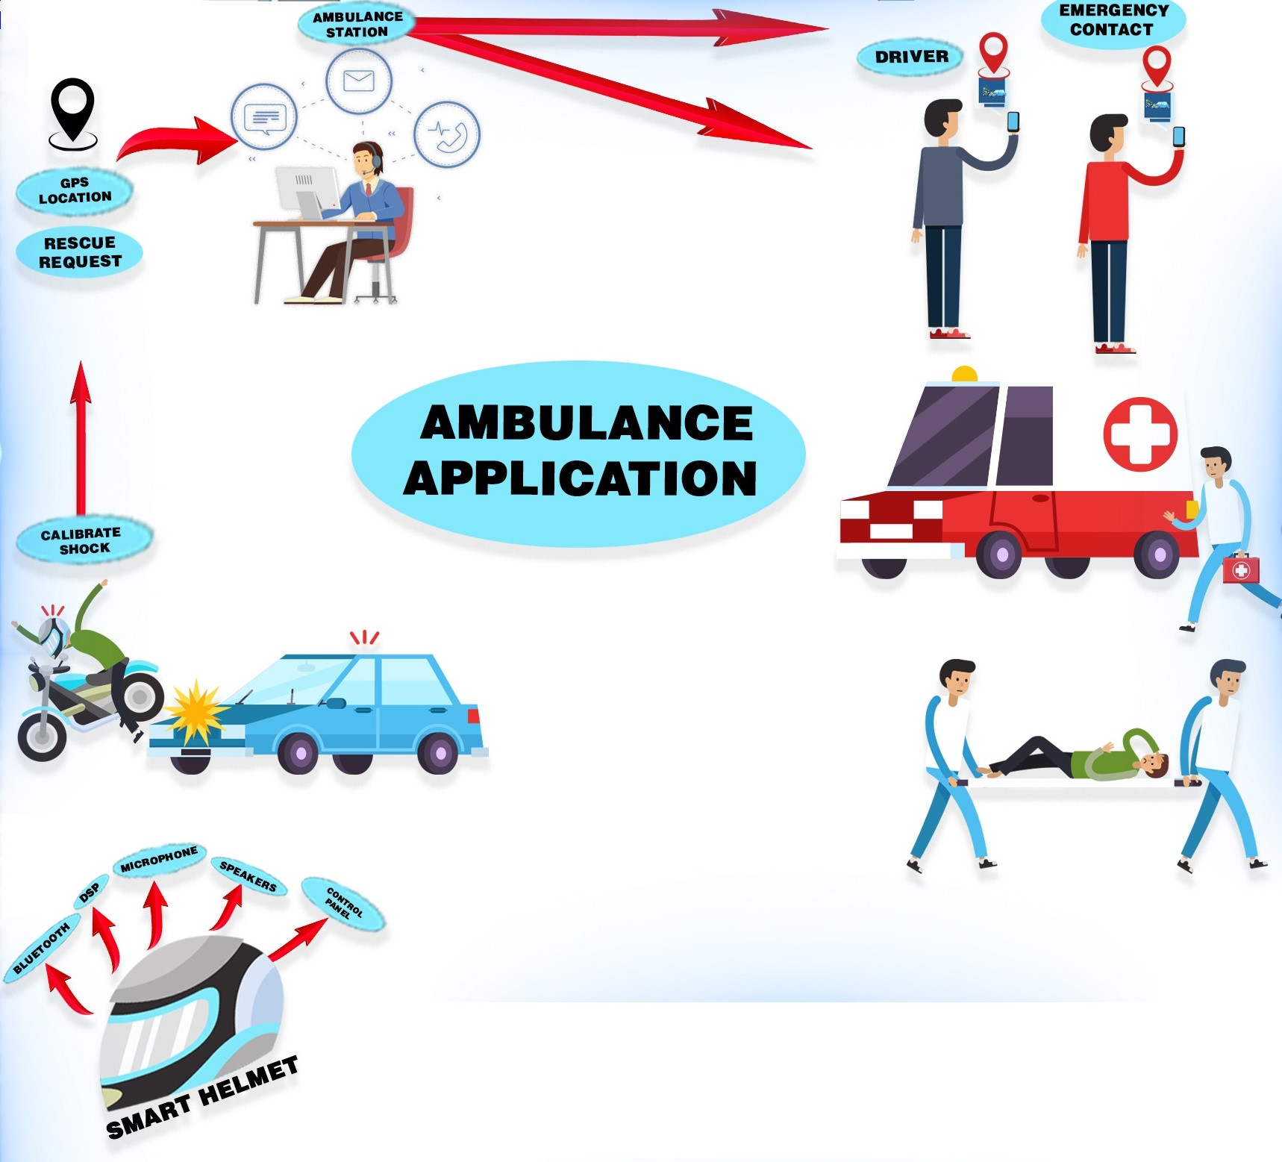

**CONCLUSION**

Motorbike is cheap and more sustainable form of transport. The motorbikes are the most registered vehicle in Pakistan.it is a less expensive but dangerous as well because of its two wheels. Motorbikes accident cause major deaths and injuries than any other. In this situation smart helmet is the need of an hour. This will reduce the possibilities of head injuries and its features such as emergency button will start the rescue process and kill button (stop button) will kill the rescue process. The rider’s location will be detected by the GPS of helmet after identifying the shock and will send to Ambulance station seeking for help. This project will make the ambulance station to work on system to maintain track and the case reports they don’t have to work manually anymore. The rescue driver can find the victim easily as it has the exact location by GPS and family member can also be notified about accident. This project is a social contribution to our society. This can reduce the death risks caused by road accident because of not getting proper medical attention at time.

LIMITATIONS:

* The area where jammers are placed the helmet will not be able to transmit the signals.
* The person wearing the helmet should have smart phone and a net connection.
* The ambulance drivers must be having smart phones.
* The ambulance drivers must be having an internet connection to view the route forwarded by the ambulance station using ambulance auto rescue app to reach to the victim

CHALANGES:

The challenges we will face in this project are:

* If the application on the ambulance station side is not working properly due to net issues.
* If the nearest ambulance station does not have availability of free ambulance, then they have to contact the other station to send the ambulance to the location detect by GPS and this may take time.
* The sensors in the helmet should not be damaged when it crashed on the ground.
* The GPS and emergency button should work properly all the time

FUTURE WORK:

* We can add camera in our helmet to start recording whenever its sensor senses the impact the front view will be recorded and can be send to the family member.
* To do the live tracking of the helmet (sending coordinates continuously).